**Integrative taxonomy uncovers a new species of upland Stream Toad of the genus *Ansonia* Stoliczka, 1870 (Anura: Bufonidae) from northeastern Peninsular Malaysia**

KIN ONN CHAN1, PERRY L. WOOD JR2, SHAHRUL ANUAR3,4, MOHD ABDUL MUIN5, EVAN S.H. QUAH3, ALEXANDRA S.-I. SUMARLI6, JACOB A. CHAN6 & L. LEE GRISMER6

*1Biodiversity Institute and Department of Ecology and Evolutionary Biology, University of Kansas, Lawrence, Kansas 66045-7561, USA. Email: chanko@ku.edu*

*2Department of Biology, Brigham Young University, 150 East Bulldog Boulevard, Provo, Utah 84602 USA*

3School of Biological Sciences, Universiti Sains Malaysia, 11800 Minden, Penang, Malaysia

4Center for Marine and Coastal Studies, Universiti Sains Malaysia, 11800 Minden, Penang, Malaysia

5Centre for Drug Research, Universiti Sains Malaysia, 11800 Penang, Malaysia.

*6Department of Biology, La Sierra University, 4500 Riverwalk Parkway, Riverside, California 92515 USA*

a) Kin Onn, Chan; chanko@ku.edu

b) Chan, Wood, Anuar, Muin, Quah, Sumarli, Chan & Grismer; New *Ansonia* from Peninsular Malaysia

c) Five plates; 31 references

d) Amphibia; one new taxon

**Abstract**

A new species of *Ansonia* is described based on genetic and morphological differentiation. *Ansonia* *lumut* **sp. nov.** is most closely related to three other Peninsular Malaysian species, *A. penangensis, A. malayana*, and *A. jeetsukumarani* but differs from these and other congeners by at least 6.9% sequence divergence at the 12S, 16S rRNA and t-RNA-val genes and the following combination of morphological characters: (1) SVL 21–23.6 mm in males, 27.7–31.6 mm in females; (2) absence of interorbital ridges and light interscapular spot; (3) presence of large, yellow rictal tubercle; (4) dorsum black with greenish-yellow reticulations; (5) flanks with small yellow spots; (6) fore and hind limbs with yellow cross-bars; and (7) venter light gray with fine, white spotting.

**Key words:** Conservation, Morphology, Phylogeny, Southeast Asia, Systematics

**Introduction**

Advances in technology have reinvigorated the field of alpha taxonomy by overcoming some of the impediments faced by traditional practices. The term “integrative taxonomy” refers to a multidisciplinary approach to taxonomy, integrating multiple lines of support to increase the accuracy of delineating species boundaries (Dayrat 2005; Schlick-Steiner *et al*. 2010; Wake 2003). Taxonomists now have a wide array of tools to choose from, including but not limited to DNA sequencing, powerful imaging technology, and statistical modeling (Fujita *et al*. 2012; Riedel *et al*. 2013; Yeates *et al*. 2011). This multisource approach is especially effective when it involves cryptic species, whereby species boundaries are obscured by morphological conservatism (Bickford *et al*. 2007; Grismer *et al*. 2012a,b; Johnson *et al*. 2012).

Recent expeditions to the poorly studied and highly fragmented Banjaran Timur (=Timur mountain range) in northeastern Peninsular Malaysia have begun to reveal the undiscovered diversity that lies therein (Dring 1979; Grismer 2006; Grismer *et al*. 2013; Wood *et al.* 2008). Our fieldwork to the previously unsurveyed Gunung Tebu (=Tebu Mountain) in the northeastern state of Terengganu uncovered a population of Stream Toad (genus *Ansonia*) that could not be readily assigned to any currently known species. This population closely matches Dring’s (1979) description of *A. malayana* Inger from Gunung Lawit, an adjacent peak on the same mountain range, but is incongruent with topotypes of true *A. malayana* from Bukit Larut, Perak from a different mountain range (Banjaran Bintang) in northwestern Peninsular Malaysia. We adopted an integrative approach, combining morphology and molecular phylogenetics to evaluate the taxonomic and phylogenetic placement of this population. Our results show that the population from Gunung Tebu represents a genetically distinct lineage that is also morphologically diagnosable. Under the Unified Concept of Species (De Queiroz 2005), we consider this separately evolving lineage as a new species with an additional secondary property of diagnosibility.

**Materials and Methods**

*Morphology*

The following characters were measured with a Mitutoyo digitmatic caliper to the nearest 0.1 mm on the left side of the body for symmetrical characters: snout–vent length (SVL), from tip of snout to vent; head length (HL), from posterior margin of mandible to tip of snout; head width (HW), measured at the level of the jaw articulation; snout length (SL), from anterior margins of eye to tip of snout; snout width (SW), distance between anterior margins of eyes; internarial distance (IND), measured from medial, inner margins of nostrils; interorbital diameter (IOD), distance between medial margins of palpebrae at its closest point; eye diameter (ED), length between anterior and posterior margins of eye; tympanum diameter (TD), length of the vertical axis; manus length (ML), distance from the proximal edge of the outer palmar tubercle to the tip of third finger; crus length (CL), distance from knee inflection to tarsal inflection; pes length (PL), measured from proximal edge of inner metatarsal tubercle to tip of fourth toe. Toe webbing formula follows Savage & Heyer (1997). The holotype was deposited at the Zoological Reference Collection at the Raffles Museum of Biodiversity Research, University of Singapore (ZRC); paratypes were deposited at La Sierra University Herpetological Collection (LSUHC), La Sierra University, Riverside, California, USA.

*Molecular phylogeny*

Genomic DNA was extracted from liver specimens stored in 95% ethanol using the animal tissue protocol in the Qiagen DNeasyTM tissue kit (Qiagen. Valencia, California). A 2685 bp fragment of the mitochondrial genes 12S, 16S rRNA and t-RNA-val were amplified using a double stranded polymerase chain reaction (PCR) under the following conditions: 1.0 μl genomic DNA, 1.0 μl of each external primer, 1.0 μl of dinucleotide pairs, 2.0 μl of 5x buffer, 1.0 μl of MgCl 10x buffer, 0.18 μl of Taq polymerase, and 7.5 μl of diH2O. All PCR reactions were carried out on an Eppendorf Mastercycler gradient thermocycler following the thermo profile in Wilkinson *et al.* (2012): initial denaturation at 94°C for 2 min, followed by 35 cycles of a secondary denaturation 94°C for 30 s, annealing at 55°C for 30 s, elongation at 72°C for 1.5 min, with a final extension at 72°C for 10 min. PCR products were visualized on a 10% agarose gel electrophoresis. PCR products that were the same size as the targeted regions were purified using MANU 30 PCR ultrafiltration (Millipore) plates and the products were re-suspended in diH2O. Purified PCR products were sequenced using an ABI Big-Dye Terminator v3.1 Cycle Sequencing Kit in an ABI GeneAmp PCR 9700 thermal cycler. All cycle sequencing reactions were purified using Sephadex G-50 Fine (GE Healthcare) and analyzed on an ABI 3730xl DNA Analyzer at the Brigham Young University Sequencing center. All primers used in this study for amplification and sequencing are presented in Table 1.

Nine new sequences (GenBank Accession numbers XX0000–XX0000) were added to previous published sequences of *Ansonia*+outgroups (Wilkinson *et al.* 2012; Matsui *et al.* 2010) and were edited and aligned in GENEIOUSv5.5.6 (Drummond *et al.* 2011). Initial alignment was constructed using the MUSCLEv3.831 algorithm (Edgar 2004) implemented in GENEIOUSv5.5.6. The alignment was than adjusted by eye in MacClade v4.08 (Maddison & Maddison 2005).

Maximum Likelihood (ML) and Bayesian Inference (BI) were used for phylogenetic reconstructions. Models of sequence evolution were based off Matsui *et al.* (2010) and Wilkinson *et al.* (2012). For both the ML and BI analyses, the datasets were partitioned by gene (three partitions). The ML analysis was performed in RAxML HPC 7.5.4 (Stamatakis *et al.* 2008) for 1000 bootstrap pseudoreplicates via the rapid hill-climbing algorithm. The Bayesian analysis was executed in MrBayes v3.2.2 (Ronquist & Huelsenbeck 2003). Two simultaneous runs were performed with eight chains per run, seven hot and one cold for 5,000,000 generations and sampling every 500 generations from the Markov Chain Monte Carlo (MCMC). After 5,000,000 generations the standard deviation of split frequencies was well below 0.01 and chain convergence was assumed. The first 10% of each run was discarded as burn-in and a Maximum Clade Credibility (MCC) tree was computed in TreeAnotator v1.7.5 (Drummond *et al.* 2012). We considered Bayesian posterior probabilities (BPP) above 0.95 and ML bootstrap support values (MLBS) greater than 70 as significantly supported (Huelsenbeck & Ronquist 2001; Wilcox *et al*. 2002). Uncorrected percent sequence divergences were calculated in Mega v5.2.1 (Tamura *et al.* 2011).

**Results**

**Phylogeny and genetic divergences.** Both Bayesian and ML analyses produced trees with largely the same topology with the exception of the placement of *Ansonia penangensis* Stoliczka and the Tebu population*.* Both trees strongly supported *A. penangensis* and the Tebu population as part of a clade containing two other Peninsular Malaysian species, *A. malayana* and *A. jeetsukumarani* Wood, Grismer, Grismer, Norhayati, Chan & Bauer (100% BPP, 99% MLBS). In the ML tree, *A. penangensis* was weakly supported to be basal to that clade (65% MLBS), with the Tebu population being sister to *A. malayana* and *A. jeetsukumarani* (53% MLBS) whereas the Bayesian tree recovered the Tebu population as basal to the clade (99% BPP), with *A. penangensis* being sister to *A. malayana* and *A. jeetsukumarani* (70% BPP) (Fig. 1). In terms of uncorrected percent sequence divergence (*p*-distance), the Tebu population is closest to *A. malayana* (6.9%), followed by *A. jeetsukumarani* (7.2%) and *A. penangensis* (7.4%). The *p*-distance between the Tebu population and other Peninsular Malaysian *Ansonia* is 8.2% (*A. endauensis* Grismer), 9.1% (*A. latirostra* Grismer), 9.2% (*A. tiomanica* Hendrickson), and 9.8% (*A. latiffi* Wood, Grismer, Grismer, Norhayati, Chan & Bauer). Other species in geographic proximity include *A. siamensis* Kiew and *A. kraensis* Matsui, Khonsue & Nabhitabhata on the Thai Peninsula, and *A. thinthinae* Wilkinson, Sellas & Vindum in southern Myanmar. From these species, the Tebu population is separated by a distance of 8.1%, 8.5%, and 8.2% respectively. Sequence divergences are summarized across all congeners in Table 2.

**Systematics.** Results from the phylogenetic analyses and morphological data clearly place the Tebu population within the genus *Ansonia*. Although its species level phylogenetic relationship can not be unambiguously resolved at this point, our results demonstrate that the *Ansonia* from Gunung Tebu represents a separately evolving lineage that can be morphologically diagnosed from all other congeners and is thus described herein as a new species.

**Species description**

*Ansonia lumut* **sp. nov.**

Fig. 2

*Ansonia malayana* Dring 1979:184

**Holotype.** Adult female (ZRC XXX) from Gunung Tebu, Terengganu, Malaysia (05°36.11’ N 102°36.19’E; 610 m a.s.l) collected on 31 August 2013 by Shahrul Anuar, Mohd. A. Muin, E. Quah, L. Grismer, B. Beltran, A. Cobos, A. Alonso, C. Thompson, and C. Ogle.

**Paratypes.** LSUHC 10899 has the same collection data as the holotype. LSUHC 11172, 11211, and 11214 were collected from the same locality as the holotype on 1 July 2013 by Chan Kin Onn, Shahrul Anuar, Mohd, A. Muin, A. Sumarli, J. Chan, H. Heinz and L. Grismer.

**Diagnosis.** *Ansonia lumut* **sp. nov.** is assigned to the genus *Ansonia* based on its phylogenetic placement and the following morphological characters: small body size; slender limbs; no parotoid glands; weak subarticular tubercles; and membranous foot webbing (Inger 1960). *Ansonia lumut* can be differentiated from all other congeners by the following combination of characters: SVL 21–23.6 mm in males, 27.7–31.6 mm in females; absence of interorbital ridges and light interscapular spot; presence of large, yellow rictal tubercle; dorsum black with greenish-yellow reticulations; flanks with small yellow spots; fore and hind limbs with yellow cross-bars; venter light gray with fine, white spotting.

**Description of holotype.** Adult female, SVL 29.3 mm; head longer than wide (HL/HW=1.12); snout wider than long (SW/SL=1.18), longer than eye diameter (SL/ED=1.46), slightly projecting beyond lower jaw, dorsally convex with a midline depression, truncated with slight median point in dorsal view, truncated and caudoventrally sloping in lateral view; canthus rostralis distinct, lores vertical, slightly concave; nares open laterally, just below canthus, nearly terminal on snout, distance between nares smaller than snout length (IND/SL=0.58), approximately half of snout width (IND/SW=0.49); eyes large, slightly protruding beyond labials in dorsal view, diameter less than snout length (ED/SL=0.68) and interorbital distance (ED/IOD=0.87), pupils circular; interorbital region flat, distance smaller than snout width (IOD/SW=0.67) and snout length (IOD/SL=0.79); tympanum distinct, oval, taller than wide, vertical diameter smaller than eye diameter (TD/ED=0.65); choanae subcircular, separated by distance larger than their diameter; vomerine ridge and teeth absent; tongue narrow, ending in median point, posterior ⅓ free.

Forelimbs and fingers long and slender; finger length from shortest to longest: I<II<IV<III; basal webbing not extending beyond proximal subarticular tubercle; tips rounded, slightly dilated but not forming discs; subarticular tubercles indistinct; inner and outer metacarpal tubercles weak, oval, flat, inner smaller than outer; supernumerary tubercles absent (Fig. 3A).

Hindlimbs and toes long and slender (CL/SVL=0.47), foot shorter than tibia (PL/CL=0.76); toe length from shortest to longest: I<II<III≤V<IV; webbing formula: I ½ – 2 II ½ – 3- III 1 – 3½ IV 3½ – 2- V; tips rounded, slightly dilated but not forming discs; subarticular tubercles indistinct; inner metatarsal tubercle elongate, flat; outer metatarsal tubercle slightly raised, oval, slightly smaller than inner (Fig. 3B).

Upper eyelid, interorbital region, dorsal part of snout and canthus covered with small, flat tubercles bearing brown, keratinized tips; interorbital ridges absent; tubercles absent on lores; single row of small spinules line the upper lip and outer margin of upper eyelid; large tubercle at posterior end of upper lip, level with anterior margin of tympanum and a larger one yet just above the rictus, posterior to the tympanum; supratympanic fold and parotoid gland absent; slight scapular swelling; back, flanks and dorsal part of limbs with irregularly spaced large and small tubercles bearing brown keratinized spinules, larger tubercles may have more than one spinule; dorsal tubercles largest around nuchal, scapular and dorsolateral region, smallest on dorsal part of limbs (Fig. 3C); entire ventral surface except for manus and pes with fine, evenly spaced spinules that are most dense around the rictal and pectoral region (Fig. 3D). Complete measurements of the holotype are presented in Table 3.

**Coloration in life.** Dorsal base color dark brown to black. Top of head, lores and back with yellow reticulations bearing greenish flecks. Large, yellow tubercle at rictus, followed anteriorly by a smaller one at the posterior end of the upper lip. An even smaller, yellow tubercle is present between the rictal and posterior upper labial tubercles on the left side of the head but absent on the right side. Three small, yellow patches along the upper lip, below the eye, lore, and rostrum. Yellow patches on ventral side of mandible. Flanks with small yellow spots. Yellow crossbars on front and hind limbs. Venter light gray with fine, white spotting.

**Coloration in preservative.** Yellow coloration creamy white and dorsal reticulations light gray. Keratinized tips on tubercles brown in color. Venter uniform creamy white with very fine dark brown stippling that are most dense on the gular region, tibia, tarsus, manus, and pes.

**Variation.** All paratypes closely resemble the holotype in coloration and pattern. Female paratypes (LSUHC 11211, 11214) have an additional yellow tubercle below the tympanum between the rictal and posterior upper labial tubercle, the tubercle on the right side larger than the one on the left. Male paratypes (LSUHC 10899, 11172) are smaller in size, SVL 21.0 mm and 23.6 mm respectively. Vocal slit present on the left size of the mouth leads into a median subgular vocal sac. Small, indistinct nuptial pad of brown asperities on medial surface of first finger between base and distal phalangeal joint. Nuptial pad not visible on LSUHC 10899. Measurements of the paratypes are presented in Table 3.

**Comparisons.** Morphological data for species comparisons were obtained from Wood *et al.* (2008), Wilkinson *et al.* (2012), and material examined (see Appendix). *Ansonia lumut* **sp. nov.** is most closely related to three other Peninsular Malaysian species, *A. malayana*, *A. penangensis,* and *A. jeetsukumarani* but can be morphologically distinguished from them by the absence of a light interscapular spot (vs. present in *A. malayana*, *A. penangensis*, and *A. jeetsukumarani*), dorsum with greenish-yellow reticulations (vs. orange hourglass-shaped lines in *A. malayana*, almost uniform black in *A. penangensis* and *A. jeetsukumarani*), large, yellow rictal tubercle (vs. whitish in *A. malayana, A. penangensis*, and *A. jeetsukumarani*), and yellow cross-bars on limbs (vs. orange in *A. malayana, A. penangensis*, and *A. jeetsukumarani*). On the Thai-Malay Peninsula and Indochina, it differs from *A. latiffi* by smaller body size in males (vs. SVL 34.1–38.2 mm) and females (vs. SVL 50.5–50.7 mm), first finger shorter than second (vs. first finger reaching tip of second), absence of tarsal ridge (vs. presence), dorsum blackish with greenish-yellow reticulations (vs. almost uniform brown), presence of large, yellow rictal tubercle (vs. absence), and yellow crossbars on limbs (vs. pale orange); from *A. latirostra* by the absence of interorbital ridges (vs. present), no rictal gland (vs. present), and greenish-yellow reticulations on dorsum (vs. almost uniform black); from *A. tiomanica* by smaller body size in males (vs. SVL 31.2 mm) and females (vs. SVL 38.4 mm), and greenish-yellow reticulations on dorsum (vs. yellow spots); from *A. endauensis* by bigger body size in males (vs. SVL 17.4 mm) and females (vs. SVL 28.5), dorsum blackish with greenish-yellow reticulations (vs. almost uniform black), and yellow crossbars on limbs (vs. orange); from *A. siamensis* by smaller body size in males (vs. SVL 28.0 mm) and females (vs. SVL 35.0 mm), finger tips not expanded into discs (vs. expanded into distinct discs), distinct dorsal tubercles (vs. reduced or absent), presence of large, yellow rictal tubercle (vs. absence), and slightly less than two phalanges free of web on fifth toe (vs. one phalanx free); from *A. kraensis* by the absence of a light interscapular spot (vs. present), presence of large, yellow rictal tubercle (vs. absence); slightly less than two phalanges free of web on fifth toe (vs. half phalanx free), dorsum with greenish-yellow reticulations (vs. dorsum brown with darker hourglass-shaped pattern), and venter light gray with fine, white spots (vs. dark brown with distinct, white reticulations); from *A. inthanon* Matsui, Nabhitabhata & Panha by larger body size in females (vs. SVL 23.3–25.2 mm), absence of light, interscapular spot (vs. presence), presence of large, yellow tubercle (vs. absence), dorsum blackish with greenish-yellow reticulations (vs. brown with lighter, indistinct markings), presence of dorsolateral row of enlarged tubercles (vs. absence), slightly less than two phalanges free of web on fifth toe (vs. one phalanx free), and venter light gray with fine, white spots (vs. brown with bright yellow blotches); from *A. thinthinae* by the absence of a light patch below eye (vs. presence), absence of light interscapular spot (vs. presence), dorsum black with greenish-yellow reticulations (vs. dark brown, lacking distinct markings), slightly less than two phalanges free of web on fifth toe (vs. half phalanx free), venter light gray with fine, white spots (vs. dark brown with yellow reticulations), and males with nuptial pads on first finger (vs. nuptial pad covering first and second fingers). Differences between the new species and other geographically and phylogenetically distant congeners are summarized in Wood *et al*. (2008: Table 1).

**Distribution and Natural History.** *Ansonia lumut* occurs in hill dipterocarp forest on Gunung Tebu (at 610 m elevation) and Gunung Lawit (at 790–1280 m elevation; Dring 1979) in the northeastern state of Terengganu (Fig 4). During the day, specimens were found in small rock cracks along a slow moving stream. The stream was approximately 5 m wide under a semi-closed canopy forest and consisted of dark-colored granite rock covered with algae and moss (Fig. 5). At night, toads were found on rocks and small, overhanging vegetation within the stream and along its banks away from strong torrent zones.

**Etymology.** The specific epithet “lumut” is derived from the Malay word for moss, in reference to the new species’ color pattern, which gives it a mossy appearance. Suggested English name: Mossy Stream Toad; Malay name: Kodok lumut

**Discussion**

Our phylogeny includes a newly discovered population of *A. jeetsukumarani* (LSUHC 11122–24) from Gunung Stong, Kelantan on the eastern side of Banjaran Titiwangsa. This population is morphologically similar to the type specimens of *A. jeetsukumarani* from Fraser’s Hill and Sungai Pergau, Kelantan and separated by 0.8% sequence divergence, indicating that these populations are conspecific and widely spread across upland regions of the Banjaran Titiwangsa (Figs. 1, 4).

Although we were unable to examine specimens of *Ansonia malayana* collected by Dring (1979) from Gunung Lawit, Terengganu, his description of the following characters clearly corresponds to *A. lumut* rather *A. malayana*: “the yellow tubercle at the mouth commissure varies in size from one half to two thirds of the tympanum diameter; fine lichenate vermiculation of green on black covering the dorsal surfaces; and ventrolateral tubercles capped with yellowish pigment”. These characters are diagnostic of *A. lumut* and absent in *A. malayana* (see species comparisons). Furthermore, Gunung Lawit is located in the same mountain range as Gunung Tebu, separated in a straight-line distance of only 20 km whereas *A. malayana* has only been confirmed to occur along the Bintang mountain range along the west coast of Peninsular Malaysia, more than 200 km to the west and separated by the extensive Banjaran Titiwangsa. Although *A. lumut* can be readily distinguished from *A. malayana* by color-pattern in life, these two species are morphometrically similar and are hard to differentiate in preserved specimens. This demonstrates the importance of capturing color images of specimens before they are preserved as many color pattern characters have diagnostic value.

The discovery of *Ansonia lumut* and species from other groups in the recent past (Grismer *et al*. 2013) highlight the understudied nature of northeastern Peninsular Malaysia and the Timur range in particular. Furthermore, our preliminary data indicate that a large amount of biodiversity is yet to be uncovered from this region, which is vital to realizing and understanding the true biodiversity of Peninsular Malaysia and Southeast Asia as a whole.

**Acknowledgements**

For field assistance we thank A. Alonso, A. Cobos, B. Beltran, C. Ogle, C. Thompson, H. Heinz, A. Loredo, and M. Yusof. For the loan of specimens we are indebted to Kelvin K. P. Lim (ZRC). We thank the Terengganu State Forestry Department for their permission to conduct research in Gunung Tebu Forest Reserve. A research pass (40/200/19 SJ.1105) was issued to LLG by the Economic Planning Unit, Prime Minister’s Department, Malaysia. This research was supported in part by grants to LLG from the College of Arts and Sciences, La Sierra University, Riverside, California, The East Texas Herpetological Society (AS.-IS) and by a Universiti Sains Malaysia grant 815075 to Shahrul Anuar. DNA sequencing was supported by J. W. Sites Jr. and the department of biology at Brigham Young University. Field work for EQSH in Malaysia was partially supported by the USM Fellowship Scheme.

**References**

Bickford, D., Lohman, D.J., Sodhi, N.S., Ng, P.K.L., Meier, R., Winder, K., Ingram, K.K. & Das, I. (2007) Cryptic species as a window on diversity and conservation. *Trends in Ecology and Evolution*, 22(3), 148–155.

Dayrat, B. (2005) Towards integrative taxonomy. *Biological Journal of the Linnaean Society*, 85, 407–415.

De Queiroz, K. (2005) A Unified Concept of Species and its consequences for the future of taxonomy. *Prooceedings of the California Academy of Sciences*, 56, 196–215.

Dring, J.C.M. (1979) Amphibians and reptiles from northern Terengganu, Malaysia, with descriptions of two new geckos: *Cnemaspis* and *Cyrtodactylus*. *Bulletin of the British Museum Natural History (Zoology),* 34, 181–241.

Drummond, A.J., Ashton, B., Buxton, S., Cheung, M., Cooper, A., Duran, C., Field, M., Heled, J., Kearse, M., Markowitz, S., Moir, R., Stones-Havas, S., Sturrock, S., Thierer, T. & Wilson, A. (2011) Geneious v5.6, available from http://www.geneious.com/

Drummond, A.J., Suchard, M.A., Xie, D., Rambaut, A. (2012) Bayesian phylogenetics with BEAUti and the BEAST 1.7. *Molecular Biology and Evolution,* 29(8),1969–1973. Doi: 10.1093/molbev/msso75

Edgar, R. (2004) MUSCLE: multiple sequence alignment with high accuracy and high throughput. *Nucleic Acids Research*, 32, 1792–1797.

Fu, J. (2000) Toward the phylogeny of family Lacertidae: why 4708 base pairs of mtDNA sequences cannot draw the picture. *Biological Journal of the Linnean* Society, 71, 203–217.

Fujita, M.K., Leaché, A.D., Burbrink, F.T., McGuire, J.A. & Moritz, C. (2012) Coalescent-based species delimitation in an integrative taxonomy. *Trends in Ecology and Evolution*, 27(9), 480–488.

Grismer, L.L. (2006) A new species of *Ansonia* Stoliczka 1872 (Anura: Bufonidae) from central Peninsular Malaysia and a revised taxonomy for *Ansonia* from the Malaya Peninsula. *Zootaxa*, 1327, 1–21.

Grismer, L.L., Wood, P.L.Jr. & Lim, K.K.P. (2012a) *Cyrtodactylus majulah*, a new species of Bent-toed Gecko (Reptilia: Squamata: Gekkonidae) from Singapore and the Riau Archipelago. *Raffles Bulletin of Zoology*, 60, 487–499.

Grismer, L.L., Wood, P.L.Jr., Quah, E.S.H., Anuar, S., Muin, M.A., Sumontha, M., Ahmad, N., Bauer, A.M., Wangkulangkul, S., Grismer, J.L. & Pauwels, O.S.G. (2012b) A phylogeny and taxonomy of the Thai-Malay Peninsula Bent-toed Geckos of the *Cyrtodactylus pulchellus* complex (Squamata: Gekkonidae): combined morphological and molecular analyses with descriptions of seven new species. *Zootaxa*, 3520, 1–55.

Grismer, L.L., Anuar, S., Muin, M.A., Quah, E.S.H. & Wood, P.L.Jr. (2013) Phylogenetic relationships and description of a new upland species of Bent-toed Gecko (*Cyrtodactylus* Gray, 1827) of the *C. sworderi* complex from northeastern Peninsular Malaysia. *Zootaxa*, 3616, 239–252.

Hedges, S.B. & Maxson, L.R. (1993) A molecular perspective on lissamphibian phylogeny. *Herpetological Monograph*, 7, 27–42.

Huelsenbeck, J. & Ronquist, F. (2001) MRBAYES: Bayesian inference of phylogeny. *Bioinformatics,* 17, 754–755.

Inger, R.F. (1960) A review of the Oriental toads of the genus *Ansonia* Stoliczka. *Fieldiana Zoology*, 39, 473–503.

Johnson, C.B., Quah, E.S.H., Anuar, S., Muin, M.A., Wood, P.L.Jr., Grismer, J.L., Greer, L.F., Chan, K.O., Norhayati, A., Bauer, A. & Grismer, L.L. (2012) Phylogeography, geographic variation and taxonomy of the Bent-toed Gecko *Cyrtodactylus* *quadrivirgatus* Taylor, 1962 from Peninsular Malaysia with the description of a new swamp dwelling species. *Zootaxa*, 3406, 39–58.

Maddison, D.R. & Maddison, W.P. (2005) MacClade 4: Analysis of Phylogeny and Character Evolution. Version 4.08a. http://Macclade.Org

Matsui, M., Tominaga, A., Liu, W., Khonsue, W., Grismer, L.L., Diesmos, A.C., Das, I., Sudin, A., Yambun, P., Yong, H., Sukumaran, J. & Brown, R.M. (2010) Phylogenetic Relationships of *Ansonia* from Southeast Asia Inferred from Mitochondrial DNA Sequences: Systematic and Biogeographic Implications (Anura: Bufonidae). *Molecular Phylogenetics and Evolution,* 54, 561–570.

Riedel, A., Sagata, K., Suhardjono, Y.R., Tänzler, R. & Balke, M. (2013) Integrative taxonomy on the fast track – towards more sustainability in biodiversity research. *Frontiers in Zoology*, 10, 15.

Ronquist, F. & Huelsenbeck, J.P. (2003) MRBAYES 3: Bayesian phylogenetic inference under mixed models. *Bioinformatics,* 19, 1572–1574.

Savage, J.M. & Heyer, R.W. (1997) Digital webbing formulae for anurans: a refinement. *Herpetological Review,* 28, 131 .

Schlick-Steiner, B.C., Steiner, F.M., Seifert, B., Stauffer, C., Christian, E. & Crozier, R.H. (2010) Integrative Taxonomy: A Multisource Approach to Exploring Biodiversity. *Annual Review of Entomology*, 55, 421–438.

Stamatakis, A., Hoover, P. & Rougemont, J. (2008) A rapid bootstrap algorithm for the RAxML web servers. *Systematic Biology,* 57, 758–771.

Tamura, K., Peterson, D., Peterson, N., Stecher, G., Nei, M., & Kumar, S. (2011) MEGA5: Molecular Evolutionary Genetics Analysis using Maximum Likelihood, Evolutionary Distance, and Maximum Parsimony Methods. *Molecular Biology and Evolution,* 28, 2731–2739.

Tominaga, A., Matsui, M., Nishikawa, K. & Tanabe, S. (2006) Phylogenetic relationships of *Hynobius naevius* (Amphibia: Caudata) as revealed by mitochondrial 12S and 16S rRNA genes. *Molecular Phylogenetics and Evolution*, 38, 677–684.

Wake, M.H. (2003) What is ‘Integrative Biology’? *Journal of Integrative and Comparative Biology*, 43, 239–241.

Wilcox, T.P., Zwickl, D.J., Heath, T.A., & Hillis, D.M. (2002) Phylogenetic relationships of the dwarf Boas and a comparison of Bayesian and bootstrap measures of phylogenetic support. *Molecular Phylogenetics and Evolution*, 25, 361– 371.

Wilkinson, J.A., Sellas, A.B., & Vindum, J. (2012) A new species of *Ansonia* (Anura: Bufonidae) from northern Tanintharyi Division, Myanmar. *Zootaxa,* 3163, 54–68.

Wood, P.L.Jr., Grismer, L.L., Norhayati, A. & Senawi, J. (2008) Two new species of torrent-dwelling toads *Ansonia* Stoliczka, 1870 (Anura: Bufonidae) from Peninsular Malaysia. *Herpetologica*, 64(3), 321–340.

Yeates, D.K., Seago, A., Nelson, L., Cameron, S.L., Joseph, L. & Trueman, J.W.H. (2011) Integrative taxonomy, or iterative taxonomy? *Systematic Entomology*, 36, 209–217.

**Appendix**

Material examined

*Ansonia jeetsukumarani*. MALAYSIA: Kelantan, Gunung Stong, LSUHC 11122–34; 11140–41.

**Tables and Figures**

Table 1. Primers used in this study for PCR amplification and sequencing reactions.

|  |  |  |  |
| --- | --- | --- | --- |
| **Primer** | **Location** | **Primer sequence 5'–3'** | **Primer reference** |
| ThrLm | External | AAARCATKGGTCTTGTAARCC | (Matsui *et al.* 2010) |
| Hedges16H1 | External | CTCCGGTCTGAACTCAGATCACGTAGG | (Hedges & Maxson 1993) |
| 12S-3H | Internal | CAAGTCCTTTGAGTTTTAAGCT | (Matsui *et al.* 2010) |
| 12SL1091 | Internal | AAACTGGGATTAGATACCCCACTAT | (Matsui *et al.* 2010) |
| 12StVal-H | Internal | AAGTAGCTCGCTTAGTTTCGG | (Matsui *et al.* 2010) |
| 12SL2021 | Internal | CCTACCGAGCTTAGTRATAGCTGGTT | (Tominaga *et al*. 2006) |
| 16SH2715 | Internal | AAGCTCCATAGGGTCTTCTCGTC | (Tominaga *et al*. 2006) |
| 16S1M | Internal | CCGACTGTTTACCAAAAACAT | (Fu 2000) |

Table 2. Uncorrected p-distances calculated for *Ansonia* using MEGA5 (Tamura *et al*. 2011).

|  |  |  |  |  |  |  |  |  |  |  |
| --- | --- | --- | --- | --- | --- | --- | --- | --- | --- | --- |
|  | *A. albomaculata* | *A. endauensis* | *A. hanitschi* | *A. inthanon* | *A. jeetsukumarani* | *A. kraensis* | *A. latiffi* | *A. latirostra* | *A. lumut* | *A. leptopus* |
| *A. albomaculata* | – |  |  |  |  |  |  |  |  |  |
| *A. endauensis* | 0.124 | – |  |  |  |  |  |  |  |  |
| *A. hanitschi* | 0.116 | 0.087 | – |  |  |  |  |  |  |  |
| *A. inthanon* | 0.126 | 0.091 | 0.095 | – |  |  |  |  |  |  |
| *A. jeetsukumarani* | 0.107 | 0.088 | 0.090 | 0.093 | – |  |  |  |  |  |
| *A. kraensis* | 0.120 | 0.082 | 0.086 | 0.069 | 0.089 | – |  |  |  |  |
| *A. latiffi* | 0.105 | 0.107 | 0.091 | 0.112 | 0.101 | 0.108 | – |  |  |  |
| *A. latirostra* | 0.117 | 0.098 | 0.088 | 0.090 | 0.082 | 0.092 | 0.101 | – |  |  |
| *A. lumut* | 0.106 | 0.082 | 0.076 | 0.093 | 0.072 | 0.085 | 0.098 | 0.091 | – |  |
| *A. leptopus* | 0.106 | 0.106 | 0.088 | 0.111 | 0.099 | 0.105 | 0.017 | 0.099 | 0.097 | – |
| *A. malayana* | 0.113 | 0.094 | 0.087 | 0.096 | 0.049 | 0.089 | 0.104 | 0.085 | 0.069 | 0.106 |
| *A. mcgregori* | 0.113 | 0.111 | 0.100 | 0.113 | 0.108 | 0.115 | 0.093 | 0.110 | 0.095 | 0.094 |
| *A. minuta* | 0.115 | 0.101 | 0.070 | 0.097 | 0.097 | 0.092 | 0.098 | 0.099 | 0.086 | 0.099 |
| *A. muelleri* | 0.112 | 0.124 | 0.105 | 0.124 | 0.118 | 0.124 | 0.100 | 0.119 | 0.102 | 0.102 |
| *A. penangensis* | 0.120 | 0.088 | 0.084 | 0.099 | 0.081 | 0.092 | 0.106 | 0.090 | 0.074 | 0.103 |
| *A. platysoma* | 0.117 | 0.089 | 0.060 | 0.091 | 0.089 | 0.091 | 0.099 | 0.086 | 0.079 | 0.095 |
| *A. siamensis* | 0.121 | 0.087 | 0.090 | 0.084 | 0.096 | 0.079 | 0.106 | 0.096 | 0.081 | 0.104 |
| *A.* sp_35066 | 0.118 | 0.079 | 0.083 | 0.065 | 0.091 | 0.053 | 0.105 | 0.087 | 0.078 | 0.102 |
| *A.* sp_38071 | 0.120 | 0.085 | 0.091 | 0.071 | 0.081 | 0.057 | 0.110 | 0.092 | 0.088 | 0.107 |
| *A. spinulifer* | 0.128 | 0.118 | 0.094 | 0.120 | 0.113 | 0.115 | 0.116 | 0.116 | 0.109 | 0.117 |
| *A. thinthinae* | 0.120 | 0.083 | 0.091 | 0.065 | 0.083 | 0.044 | 0.109 | 0.085 | 0.082 | 0.109 |
| *A. tiomanica* | 0.130 | 0.104 | 0.097 | 0.096 | 0.095 | 0.096 | 0.119 | 0.094 | 0.092 | 0.115 |
| *A. torrentis* | 0.097 | 0.102 | 0.085 | 0.105 | 0.094 | 0.098 | 0.048 | 0.102 | 0.091 | 0.048 |

Table 2 continued

|  |  |  |  |  |  |  |  |  |  |  |  |  |
| --- | --- | --- | --- | --- | --- | --- | --- | --- | --- | --- | --- | --- |
| *A. malayana* | *A. mcgregori* | *A. minuta* | *A. muelleri* | *A. penangensis* | *A. platysoma* | *A. siamensis* | *A.* sp_35066 | *A.* sp_38071 | *A. spinulifer* | *A. thinthinae* | *A. tiomanica* | *A. torrentis* |
|  |  |  |  |  |  |  |  |  |  |  |  |  |
|  |  |  |  |  |  |  |  |  |  |  |  |  |
|  |  |  |  |  |  |  |  |  |  |  |  |  |
|  |  |  |  |  |  |  |  |  |  |  |  |  |
|  |  |  |  |  |  |  |  |  |  |  |  |  |
|  |  |  |  |  |  |  |  |  |  |  |  |  |
|  |  |  |  |  |  |  |  |  |  |  |  |  |
|  |  |  |  |  |  |  |  |  |  |  |  |  |
|  |  |  |  |  |  |  |  |  |  |  |  |  |
|  |  |  |  |  |  |  |  |  |  |  |  |  |
| – |  |  |  |  |  |  |  |  |  |  |  |  |
| 0.115 | – |  |  |  |  |  |  |  |  |  |  |  |
| 0.100 | 0.108 | – |  |  |  |  |  |  |  |  |  |  |
| 0.119 | 0.038 | 0.109 | – |  |  |  |  |  |  |  |  |  |
| 0.082 | 0.107 | 0.096 | 0.112 | – |  |  |  |  |  |  |  |  |
| 0.090 | 0.102 | 0.075 | 0.110 | 0.086 | – |  |  |  |  |  |  |  |
| 0.101 | 0.111 | 0.095 | 0.119 | 0.093 | 0.089 | – |  |  |  |  |  |  |
| 0.092 | 0.109 | 0.091 | 0.117 | 0.093 | 0.091 | 0.070 | – |  |  |  |  |  |
| 0.090 | 0.110 | 0.095 | 0.121 | 0.086 | 0.094 | 0.084 | 0.064 | – |  |  |  |  |
| 0.114 | 0.123 | 0.101 | 0.127 | 0.111 | 0.103 | 0.124 | 0.113 | 0.116 | – |  |  |  |
| 0.091 | 0.109 | 0.095 | 0.124 | 0.091 | 0.089 | 0.076 | 0.057 | 0.065 | 0.110 | – |  |  |
| 0.097 | 0.123 | 0.107 | 0.133 | 0.102 | 0.095 | 0.101 | 0.088 | 0.100 | 0.124 | 0.095 | – |  |
| 0.102 | 0.086 | 0.102 | 0.096 | 0.099 | 0.088 | 0.100 | 0.098 | 0.101 | 0.114 | 0.101 | 0.119 | – |

Table 3. Measurements of the type series summarized by gender. Ranges follow mean ± standard error.

|  |  |  |  |  |  |  |  |
| --- | --- | --- | --- | --- | --- | --- | --- |
|  | ZRC XXX Holotype | LSUHC 11214 Paratype | LSUHC 11211 Paratype | Mean ± Std Error Min–Max | LSUHC 11172 Paratype | LSUHC 10899 Paratype | Mean ± Std Error Min–Max |
| sex | f | f | f | Female (n=3) | m | m | Male (n=2) |
| SVL | 29.3 | 27.7 | 31.6 | 29.5 ± 1.1 27.7–31.6 | 23.6 | 21 | 22.3 ± 1.3 21.0–23.6 |
| HL | 8.5 | 8.2 | 10 | 8.9 ± 0.6 8.2–10.0 | 7.1 | 6.9 | 7.0 ± 0.1 6.9–7.1 |
| HW | 7.6 | 7.4 | 8.5 | 7.8 ± 0.3 7.4–8.5 | 6.6 | 6.3 | 6.5 ± 0.2 6.3–6.6 |
| SL | 3.8 | 3.3 | 4 | 3.7 ± 0.2 3.3–4.0 | 3.3 | 3.1 | 3.2 ± 0.1 3.1–3.3 |
| SW | 4.5 | 4.2 | 4.6 | 4.4 ± 0.1 4.2–4.6 | 3.8 | 3.3 | 3.6 ± 0.3 3.3–3.8 |
| IND | 2.2 | 2.3 | 2.4 | 2.3 ± 0.1 2.2–2.4 | 2 | 1.8 | 1.9 ± 0.1 1.8–2.0 |
| IOD | 3 | 3 | 3.3 | 3.1 ± 0.1 3.0–3.3 | 2.7 | 2.2 | 2.5 ± 0.3 2.2–2.7 |
| ED | 2.6 | 2.6 | 3.1 | 2.8 ± 0.2 2.6–3.1 | 2.4 | 2.3 | 2.4 ± 0.1 2.3–2.4 |
| TD | 1.7 | 1.6 | 1.8 | 1.7 ± 0.1 1.6–1.8 | 1.6 | 1 | 1.3 ± 0.3 1.0–1.6 |
| ML | 7.8 | 7.4 | 8.6 | 7.9 ± 0.4 7.4–8.6 | 6.2 | 5.5 | 5.9 ± 0.4 5.5–6.2 |
| CL | 13.9 | 13.7 | 15.7 | 14.4 ± 0.6 13.7–15.7 | 11.6 | 10.9 | 11.3 ± 0.4 10.9–11.6 |
| PL | 10.5 | 10.5 | 11.3 | 10.8 ± 0.3 10.5–11.3 | 8.4 | 7.7 | 8.1 ± 0.4 7.7–8.4 |



Fig. 1. Bayesian phylogeny of *Ansonia* based on 2685 bp fragment of the mitochondrial genes 12S, 16S rRNA and tRNA-val. Nodal support are indicated by Bayesian posterior probabilitiy (BPP) / Maximum Likelihood bootstrap (MLBS). Dashes indicate nodes that were not supported in the ML analysis.

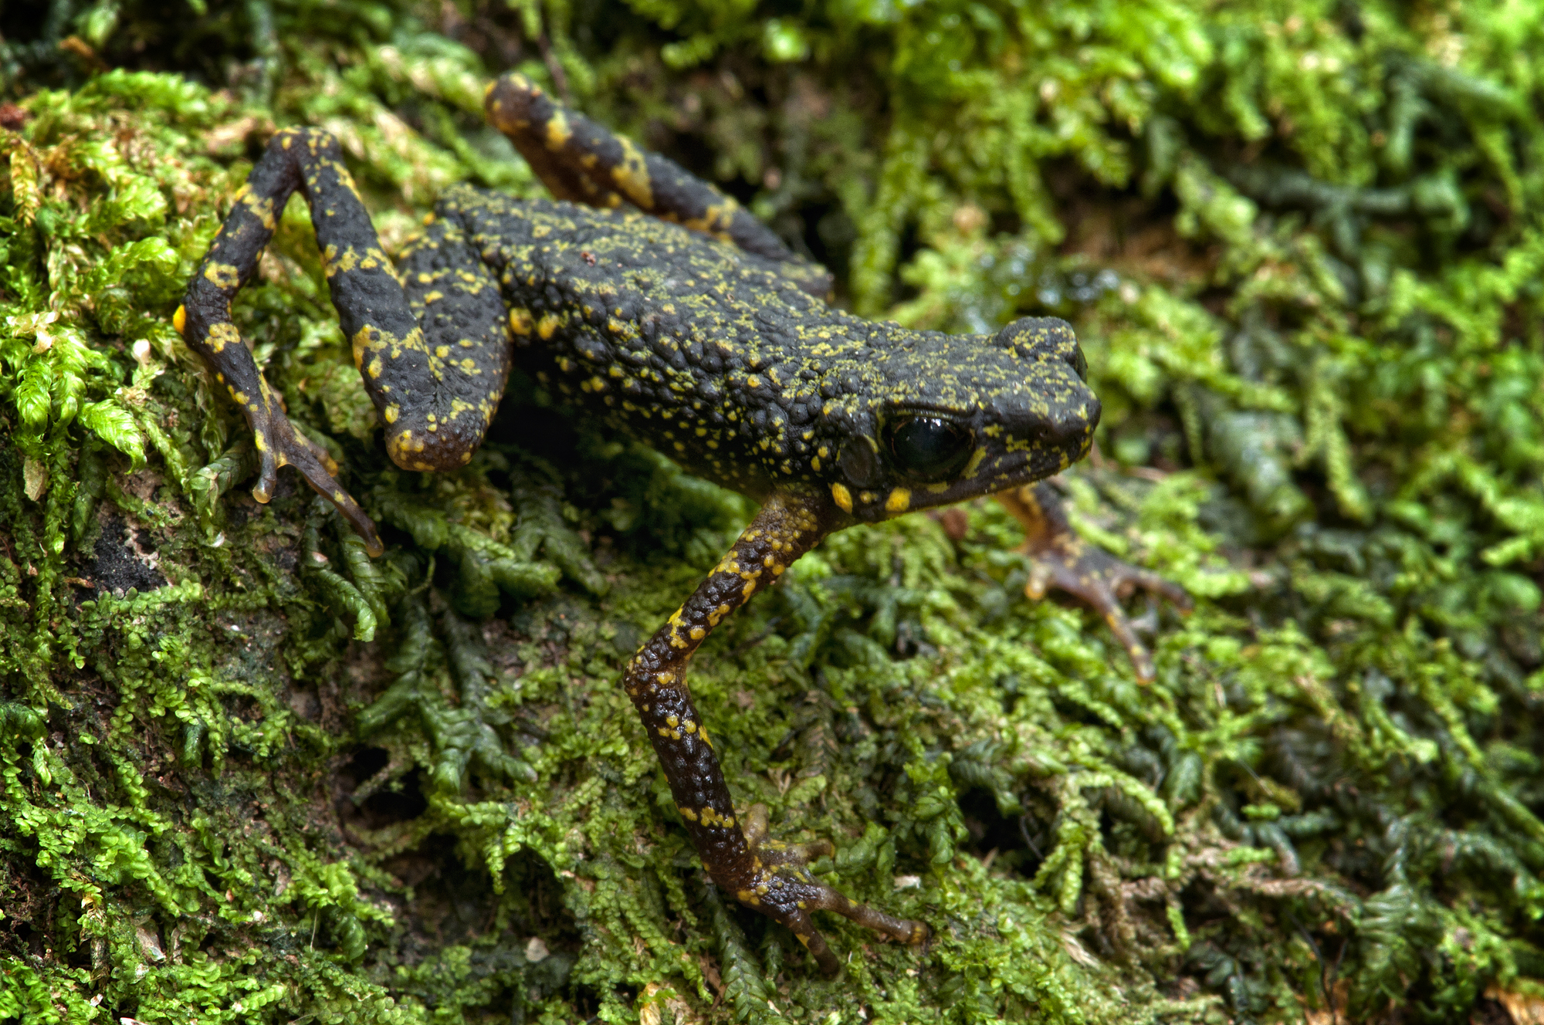

Fig. 2. Live coloration of *Ansonia lumut* from Gunung Tebu, Terengganu.

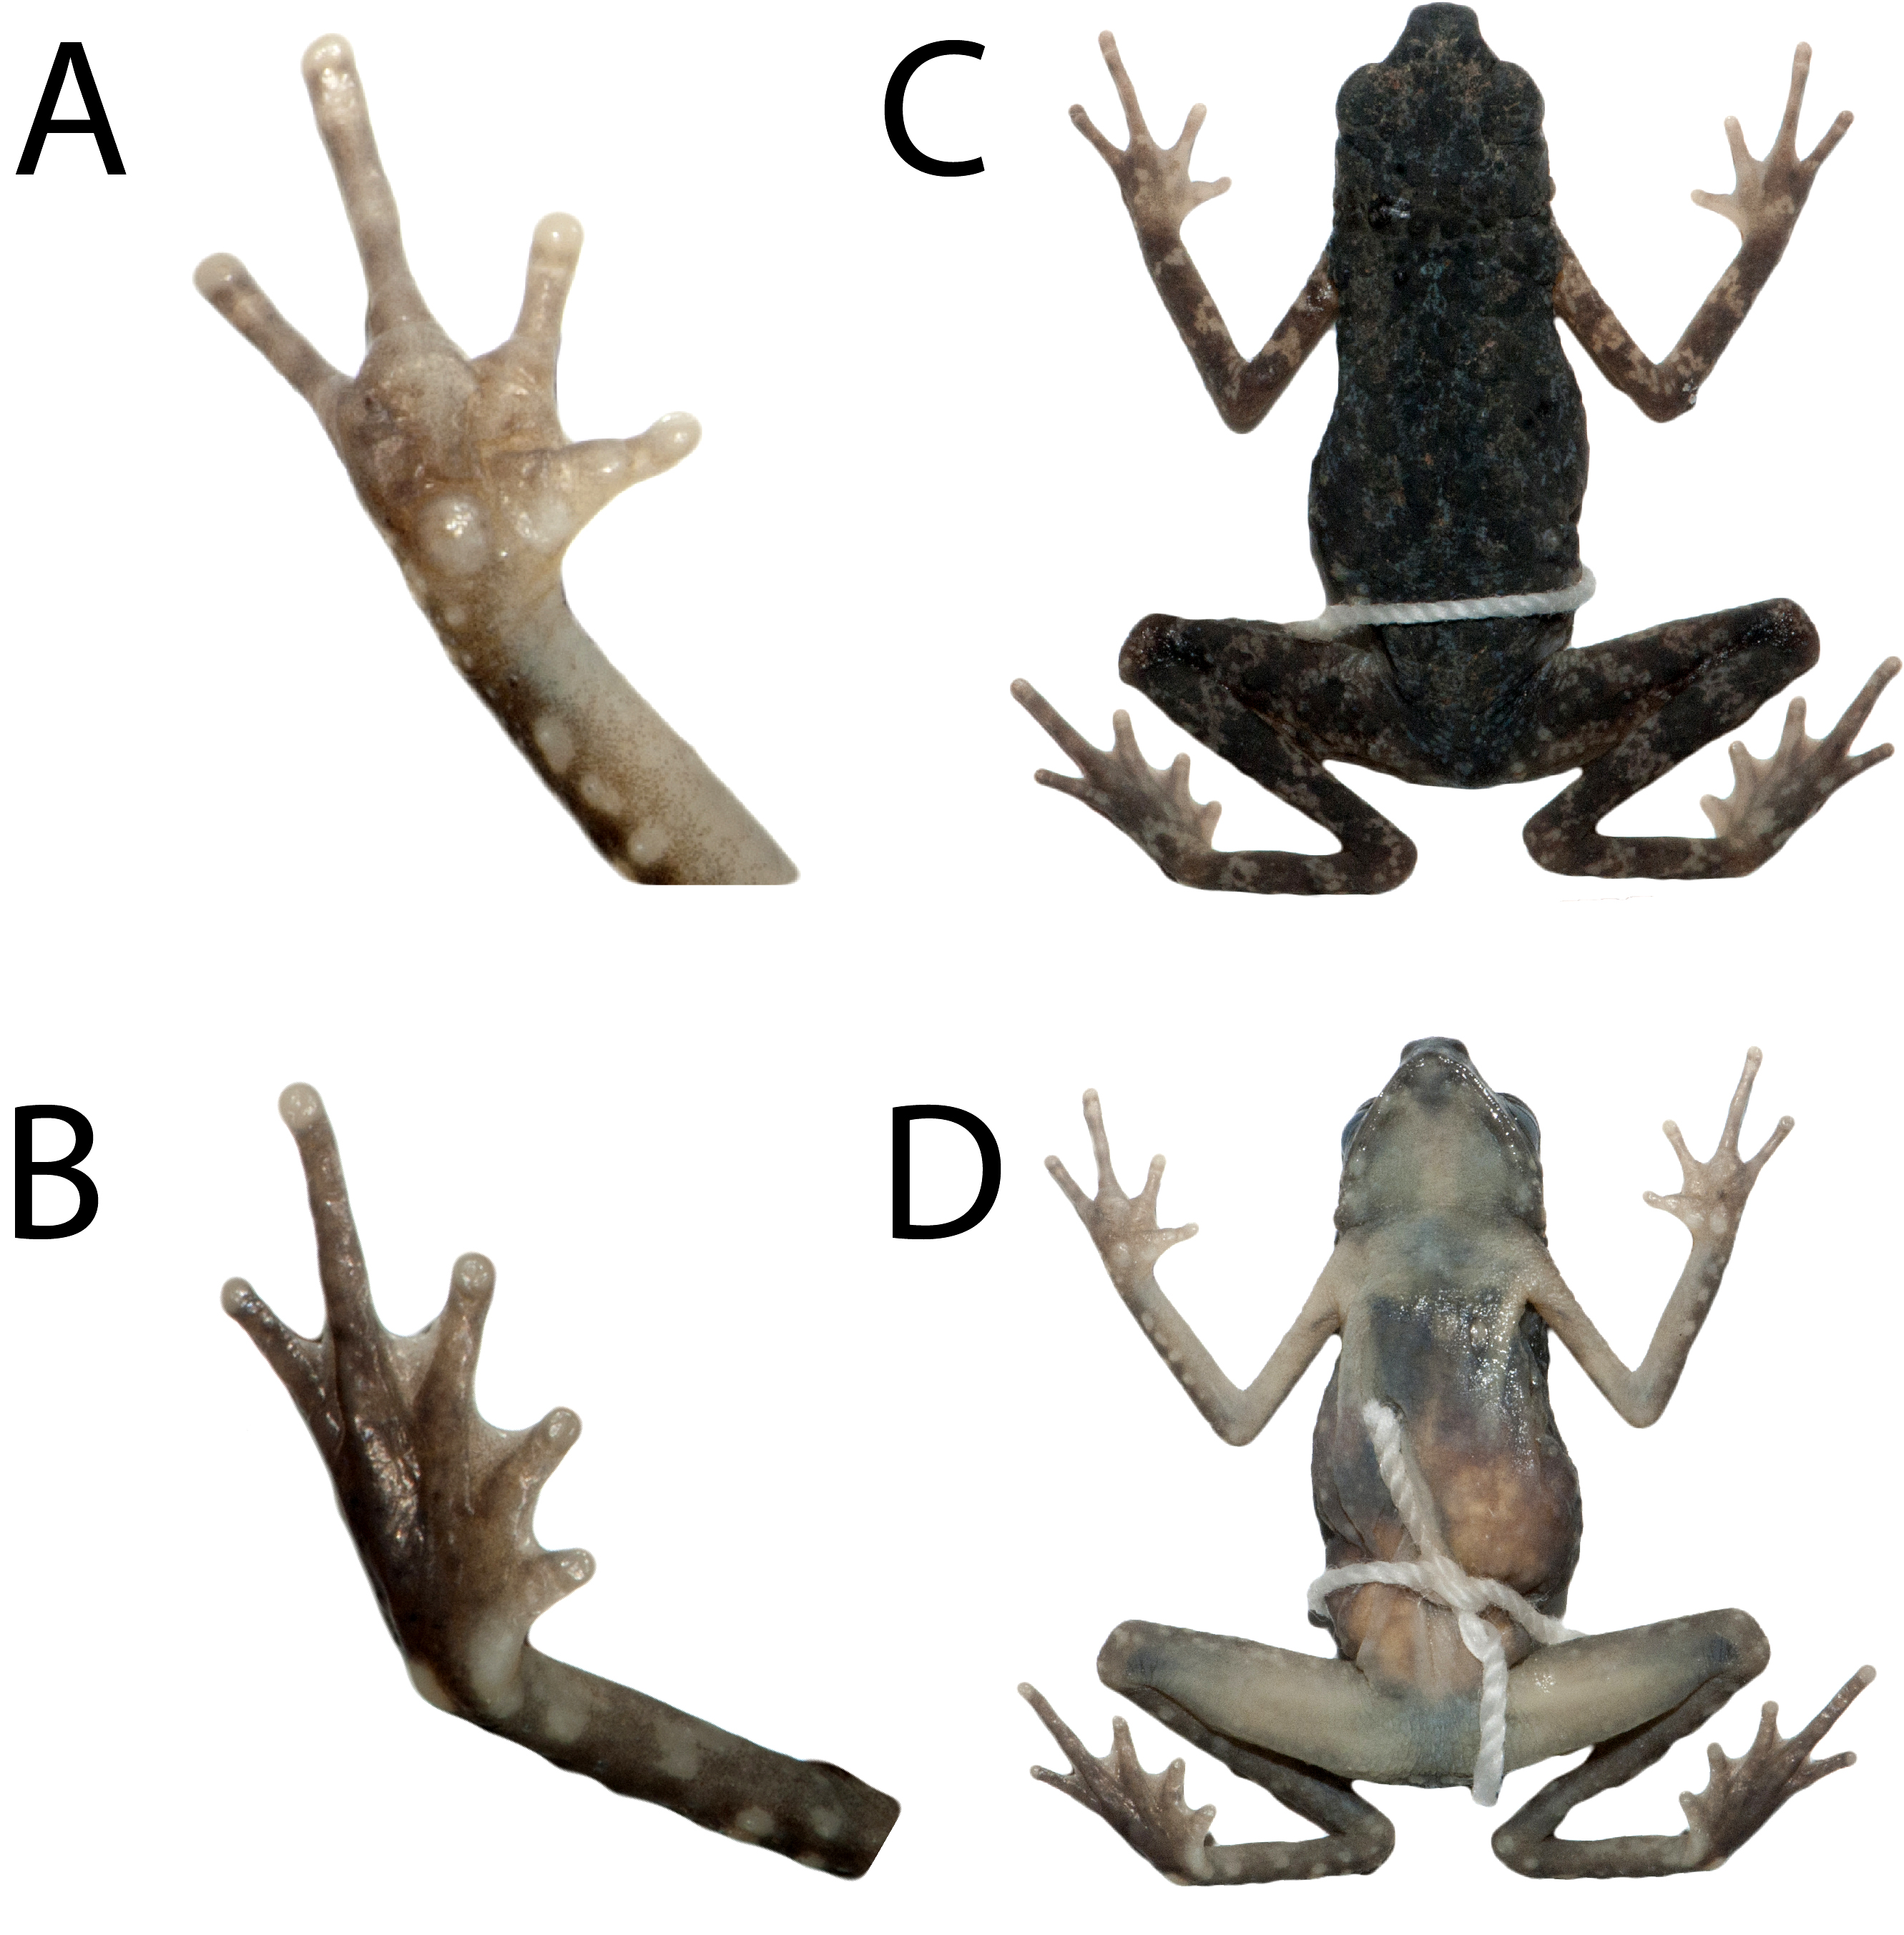

Fig. 3. Holotype of *Ansonia lumut*. A: Ventral view of right manus; B: Ventral view of right pes; C: Dorsal surface; D: Ventral surface.

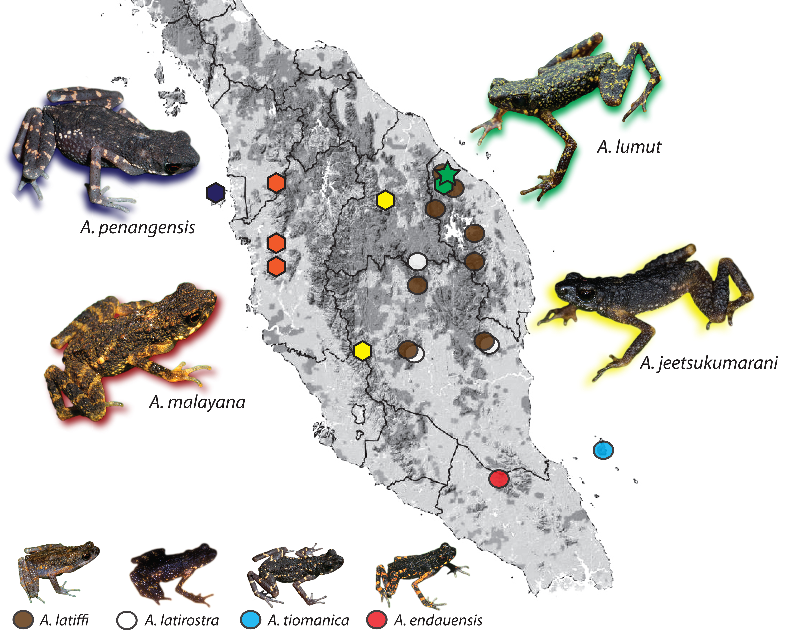

Fig. 4. Distribution of *Ansonia* in Peninsular Malaysia. Localities are color coded to corresponding species. Star denotes the type locality of *A. lumut*; polygons denote members in the *A. lumut* clade; circles denote members outside of the *A. lumut* clade.

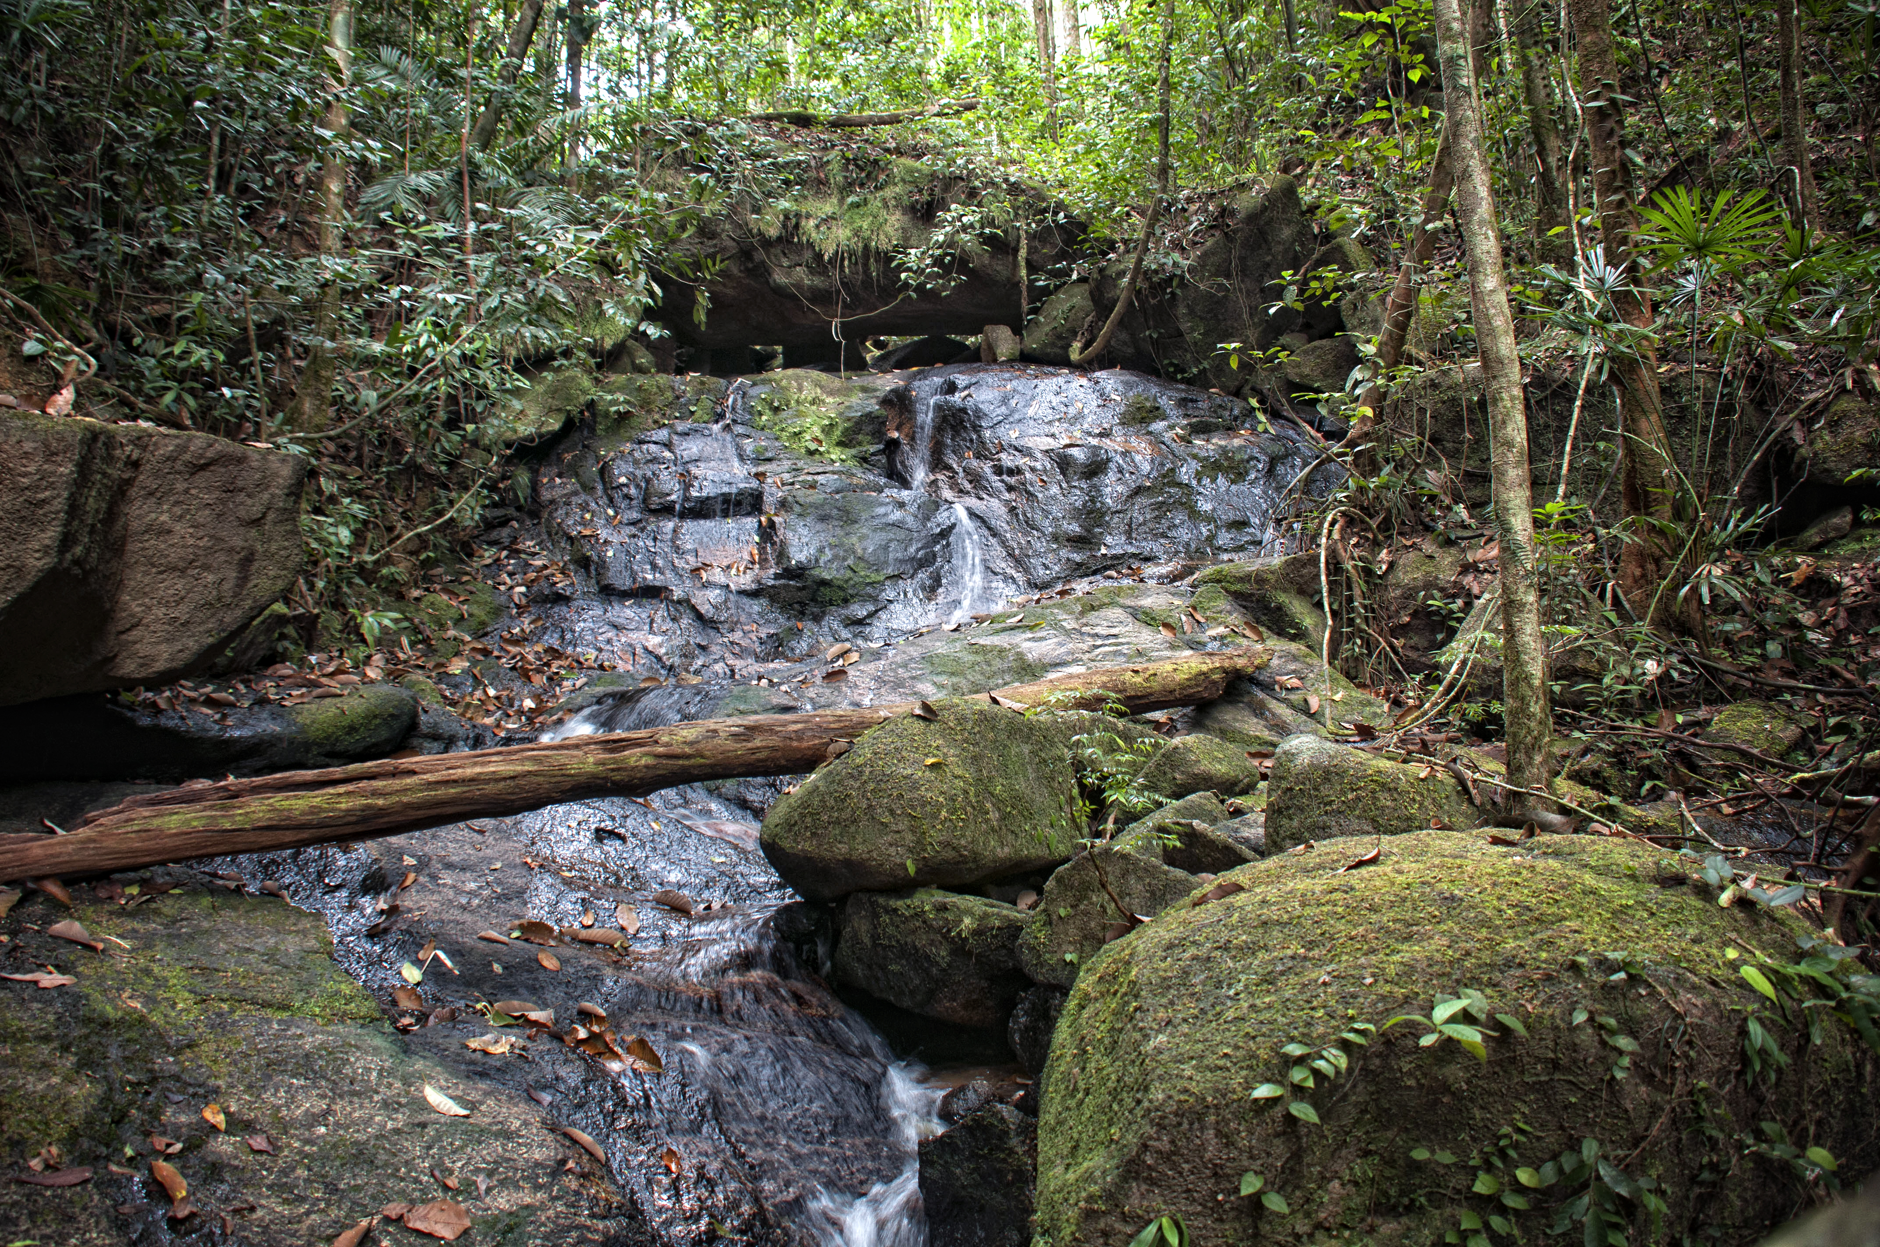

Fig. 5. Habitat of *Ansonia lumut* at Gunung Tebu, Terengganu.